|  |
| --- |
| Macintosh HD:Users:owner:Downloads:logo.jpgJARGON CORP. |
| External Documentation |
| **[Slot Machine]** |
| Version #0.6  All work Copyright © 2012 by JARGON CORP.  All rights reserved. |
| **Jesse Higgins** |
|  |

|  |
| --- |
| June 6th 2013 |

**Table of Contents**

1. Version History
2. Game Description
3. Controls
4. Interface Sketch
5. Screen Descriptions
6. Scoring
7. Art/Multimedia Index

**Version History**

**Version 0.1:**

This was the initial step of my slot machine. I simply just fooled around with pygame and loaded a background image for the base of the slot machine game.

**Version 0.2:**

Added the first button to the game and added functions that would change the button image when the users mouse position was hovered over the button. There was also a check for if the button was pushed down over the button to load a third image to represent the clicking.

**Version 0.3:**

Implemented multiple buttons for the game all with the same hover, click, and original functions. The Button class was also made dynamic now so to create a button or change the buttons image, you would now have to pass in a filename.

**Version 0.4**:

In version 0.4, I implemented labels to display bet values, player’s money and payout for each spin if any existed. I also started connecting the buttons to the game and gave them functionality.

**Version 0.5**:

Version 0.5 was simply the next step, which involved adding images to the slot reels and connecting them to the game to show up for each spin to represent the fruits that were spun.

**Version 0.6**:

Version 0.6 was the final upload with sound implementation. Sounds included were for Payout, Spinning, and just background slots style music. This version also included a new frame image that would surround the slot machine and had an array of images to present an animation effect. Also, file paths were cleaned up and organized.

**Link to view Version History on GitHub:** [**https://github.com/JargonKnight/Intro-To-Graphics/tree/master/Assignment%202**](https://github.com/JargonKnight/Intro-To-Graphics/tree/master/Assignment%202)

1. **Game Overview**

**This is Slot Machine game. The user begins with 1000 credits, and has the options to Spin the slots, increase his/her bet and can even cash out or reset the game. The object of the game is simple and that is to win as much money as you can. There are a couple classes that are used just to display sprites on the screen for updating the user on his/her current values such as how much they are betting or how much money they have left and of course how much they have just won. There are buttons that have hover, click, and original functions that take a filename for the button and update the image based on the users actions. There are a few fucntions that work together in order to put together the fruits or the bet line as some would say, and then update the images to display the corresponding fruit on the reels. These functions also determine the value of how much the user has won, if any. Each time the user spins, if they win, there is extra background that gives the user an opportunity at a jackpot.**

1. **Controls**

**The controls for the slot machine game are very simply. There are buttons on the screen that the user interacts with simply by clicking on them. There is a spin button, that creates the fruits and updates the players money and cash out and jackpot values. There is the Bet button, which increases the players bet by Increments of 5 starting from 10, and no more than 100. There is a max bet button that sets the bet straight to 100. Finally the reset button will reset the initial values of the game and the cash out button will close the game entirely.**

1. **Screen Sketch**

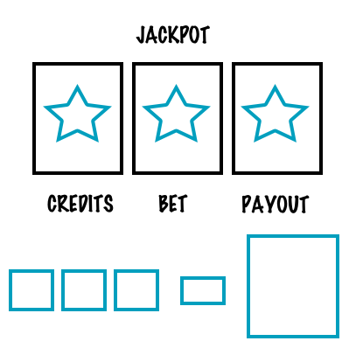

1. **Screen Description**

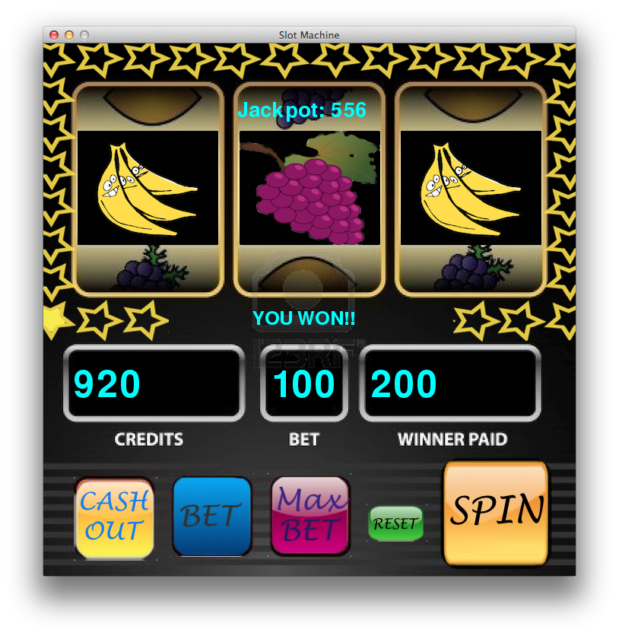

**This is the Slot machine game. Version 0.6 is the final version displayed above that shows the updated labels including a message telling the user they won and it includes all the function buttons.**

1. **Scoring**

The scoring of the slot machine game is simple. After the user decides to spin, the bet value is taken into a function that determines the selected fruits and using a formula, based on how many of each fruit and the bet line in general, the bet value will be multiplied by the bet lines value and will be added to the users money if he/she has won. With each spin as well, 15% of the users bet goes to the jackpot.

1. **Art/Multimedia Index**

Several multimedia aspects take over in this game. A few sound clips are used to enhance the user experience. These sound clips consist of: slotSpinSound.ogg, slotWinSound.ogg, and bgSlotMusic.ogg. There are several images used for the buttons and reels as well. A few are listed below:

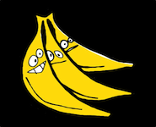  

banana.png bell.png maxBetButton1.png